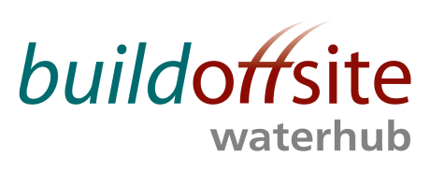
WATER HUB Leads MONTHLY CONFERENCE CALL

Date: Wednesday 11th October 2017

Time: 15:30 – 16:30

Skype: Join Skype Meeting

In Person: Buildoffsite Meeting Room at the Offsite Construction Show
(Contact Louise Smith if attending in person)

Phone: 020 307 87637 Access code: 74947451

AGENDA

Item | Timing | Subject | Lead
1. | 15:30 – 15:35 | Welcome & Introductions | JR
2. | 15:35 | Competitions Act Agreement* | JR
3. | 15:35 – 15:45 | Actions from previous meetings  Action Log and draft Minutes attached | JR
4. | 15:45 – 16:10 | - Update on recent activities and Events  - Roadmap projects | JR
5. | 16:10 – 16:20 | Information Management and Engagement | JR
6. | 16:20 – 16:25 | Future events | JR
67. | 16:25 – 16:30 | AOB | All

* Competitions Act agreement - members participating in this call certify that they will not at any time whilst on the call engage in any form of anti-competitive practices including exchanges of price information. In addition, exchange of other financial or sales information is prohibited where, for example, it is possible to disaggregate information to identify participants.
INVITEES:
Jon Rains – Mott Macdonald (Chair)
Chris Peel – Anglian Water
Steve Hough – Balfour Beatty
Steve Fozard - Costain
David Marsh – Laing O’Rourke
Gavin Stonard - Nomenca
John Browne – United Utilities
Stephen Wright – Yorkshire Water
Daniel Jefferson – Yorkshire Water
Jamie Johnston – Bryden Wood
Steve Weston – Ross-shire Engineering
Stephen Kennedy - MWH

