Buildoffsite Response to CLC's Roadmap to Recovery Plan

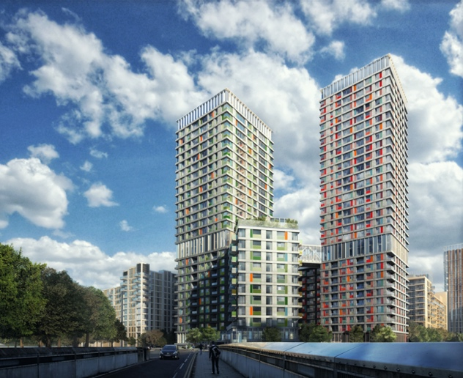
- *TEXT PLACEHOLDER* - Please replace with your own

“A Buildoffsite response to the ‘CLC roadmap to recovery guide’”, how can the offsite sector step up and support the new 3 point strategy
• Restart: increase output, maximise employment and minimise disruption (0-3 months)
• Reset: drive demand, increase productivity, strengthen capability in the supply chain (3-12 months)
• Reinvent: transform the industry, deliver better value, collaboration and partnership (12-24 months)

3.0 Brief to Supply Chain Partners
Further to the Construction Leadership Council’s publication of their 3 stage post-Covid 19 industry recovery roadmap, Buildoffsite, as one of the CLC’s Industry Partners, is contributing to this initiative by engaging the offsite industry to understand their plans to manage the Covid-19 recovery.
CLC identify the 3 recovery stages as:
1. Restart
2. Reset
3. Reinvent
As such, we request the offsite supply chain & wider consulting community to provide an overview on how offsite can, and will deliver against the 3 targets? Please give real examples from your business not just anecdotal evidence, this is the chance to show the CLC and the wider industry how offsite can step up to the challenge.
We require 500-600 words and images to take up 3 A4 pages maximum due by 30th June 2020.
Some sample thoughts on the types of things to include below (please use as a guide only, not as questions to answer).
- What measures have you put in place to physically maintain social distance measures?
- Will more of your staff and consultants operate remotely?
- Are you increasing investment in information technology as a result of the Covid-19 impacts?
- What measures are you putting in place to benchmark the pre-Covid19 financial and productivity position to robustly identify the time and cost impacts?
- Do you consider that a post-Covid-19 Industry will increase or decrease offsite manufacturing & DfMA?
- Do you envisage a change to the offsite market, say less hotels, more social housing, less offices etc. due to Covid-19?
- Will you increase the use of BIM and Tech software as a result of Covid-19?
- Will you increase the use of automation during production as a result of Covid-19?
- By production percentage (using February 2020 as 100%) what percentage production rates do you envisage at June 2020, June 2021 & June 2022?

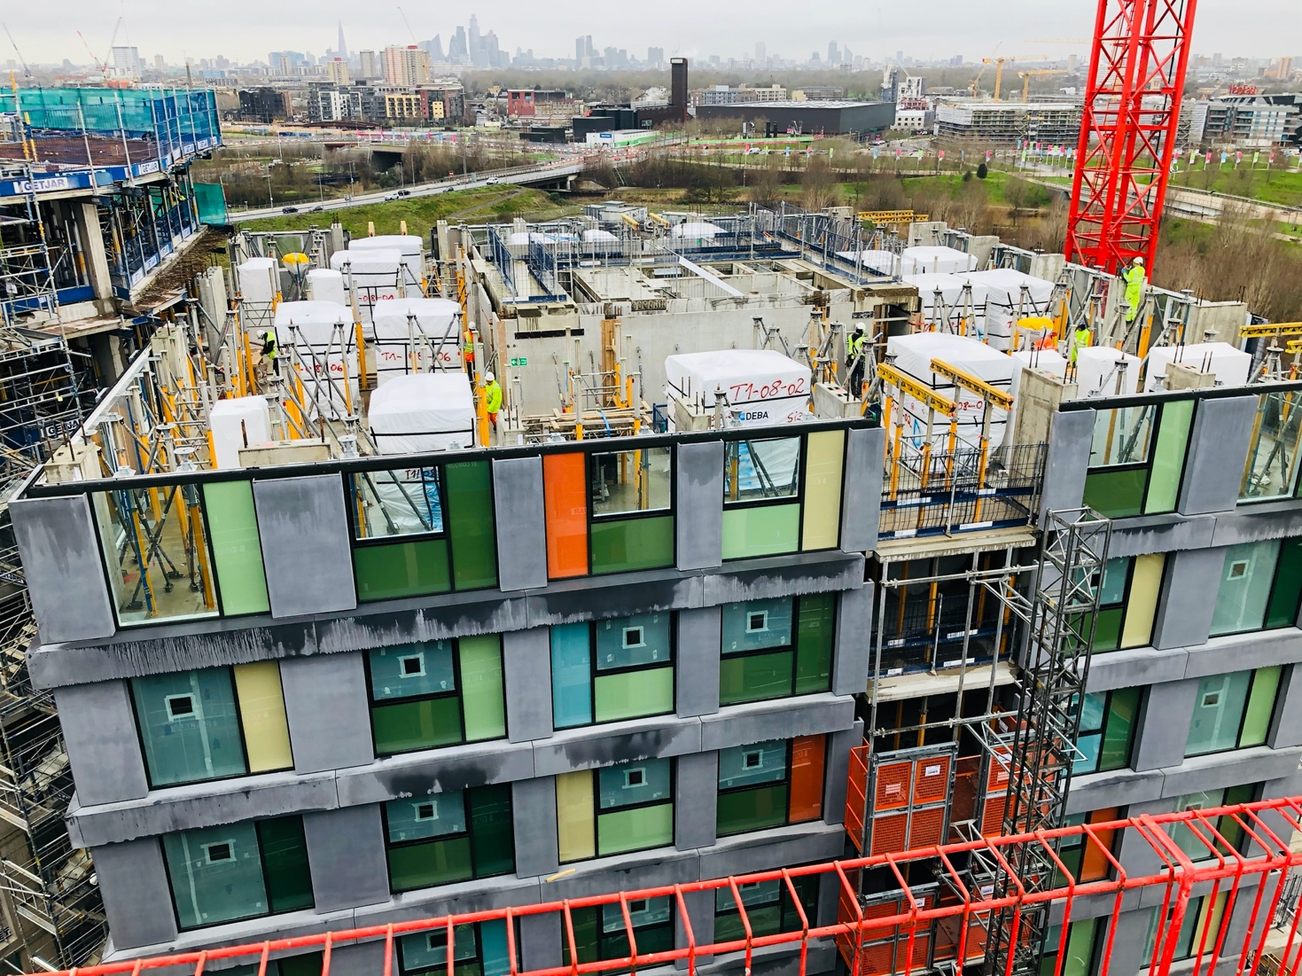

TEXT Placeholder
