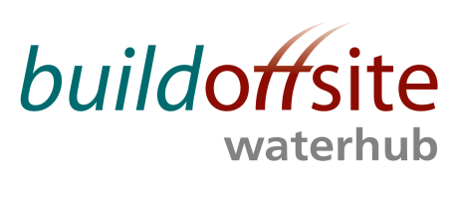
WATER HUB Leads MONTHLY CONFERENCE CALL

Date: Friday 8th December 2017

Time: 08:30 – 09:30

Skype: Join Skype Meeting

Phone: 020 307 87637 Access code: 21244583

AGENDA

Item | Timing | Subject | Lead
1. | 08:30 – 08:35 | Welcome & Introductions | JR
2. | 08:35 | Competitions Act Agreement* | JR
3. | 08:35 – 08:45 | Actions from previous meetings  Action Log and draft Minutes attached | JR
4. | 08:45 – 09:10 | - Update on recent activities and Events (including Client Group Meeting on 29th November)  - Roadmap projects | JR
6. | 09:10 – 09:25 | Future events | JR
67. | 09:25 – 09:30 | AOB | All

* Competitions Act agreement - members participating in this call certify that they will not at any time whilst on the call engage in any form of anti-competitive practices including exchanges of price information. In addition, exchange of other financial or sales information is prohibited where, for example, it is possible to disaggregate information to identify participants.
INVITEES:
Jon Rains – Mott Macdonald (Chair)
Steve Hough – Balfour Beatty
Steve Fozard - Costain
David Marsh – Laing O’Rourke
Gavin Stonard - Nomenca
John Browne – United Utilities
Stephen Wright – Yorkshire Water
Jamie Johnston – Bryden Wood

