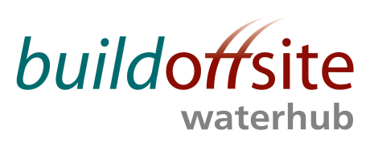
WATER HUB CLIENT PRODUCT GROUP Quarterly meeting

Date: Wednesday 29th November 2017

Time: 09:30 – 16:30

Venue: Scottish Water, Lomond Suite 4, Buchanan Gate Business Park, Cumbernauld Road, Stepps G33 6FB

AGENDA
Item | Timing | Subject | Lead
 | 09:30 – 09:35 | Welcome & Introductions  Including one team working across the client group/supply chain | JR
 | 09:35 – 09:40 | Competitions Act Agreement* | JR
 | 09:40 – 09:50 | Actions from previous meetings | JR
 | 09:50 -10:30 | Front of Mind  Short summary for each person and an opportunity for others to listen. | ALL
 | 10:30 – 12:00 | Roadmap and Projects: Client Ownership:  Developing a collective vision diagram for the group (network, message, communication, knowledge) | JR
 | 12:00- 12:30 | LUNCH
 | 12:30 – 12:45 | Anglian Water: time-lapse video of a build off site/industrialised construction | MF
 | 12:45 – 13:45 | BIM 4 Water: | JM
 | 13:45 – 14:45 | Water Company Standards:  Aligning water company standards and specifications | JR
 | 14:45 – 15:00 | BREAK
 | 15:00 – 16:00 | Communication & Terminology  Building our Water Hub lexicon of terms to ensure clear communication (i.e. Network / System / Asset / Assembly / component) | JR
 | 16:00 – 16:30 | Wrap up & AOB | JR

* Competitions Act agreement – members & guests participating in this meeting certify that they will not at any time whilst on the call engage in any form of anti-competitive practices including exchanges of price information. In addition, exchange of other financial or sales information is prohibited where, for example, it is possible to disaggregate information to identify participants.
INVITEES:
Jon Rains – Mott Macdonald (Chair)
Mark Froggatt – Anglian Water
Derek Keeling – Welsh Water
TBC – Thames Water
Iain MacDonald – Scottish Water
Sharon Hamilton – Scottish Water
John Browne – United Utilities
Stephen Wright – Yorkshire Water
Frederic Aujoux – Northumbrian Water
Martin Vickers – South Staffs Water
Jack McCarey – South West Water
Charlotte Davidson – Severn Trent
Ian Corder – Environment Agency

Guests:
Jamie Mills – Xylem

