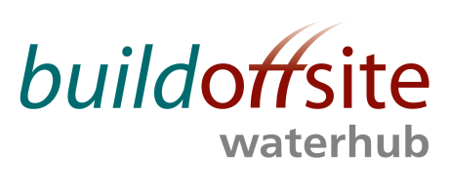
WATER HUB CLIENT PRODUCT GROUP CONFERENCE CALL

Date: Wednesday 25th October 2017

Time: 09:30 – 11:00

Skype Link: Join Skype Meeting

Dial in Details: 020 3078 7637 Access Code: 93201906

Item | Timing | Subject | Lead
 | 09:30 – 09:35 | Welcome & Introductions | JR
 | 09:35 | Competitions Act Agreement* | JR
 | 09:35 – 09:45 | Actions from Previous meetings | JR
 | 09:45 -10:00 | Front of Mind:  Short summary for each person and an opportunity for other to listen. | JR
 | 10:00 – 10:20 | Water Company Standards:  Aligning water company standards and specifications | JR
 | 10:20 – 10:40 | Roadmap and Projects  Developing a collective vision diagram for the group (network, message, communication, knowledge) | ALL
 | 10:40– 10:50 | Terminology  Building our Water Hub lexicon of terms to ensure clear communication (i.e. Network / System / Asset / Assembly / component) | ALL
 | 10:50 – 10:55 | Support for Upcoming Events | ALL
 | 10:55 – 11:00 | AOB | All

* Competitions Act agreement - members participating in this call certify that they will not at any time whilst on the call engage in any form of anti-competitive practices including exchanges of price information. In addition, exchange of other financial or sales information is prohibited where, for example, it is possible to disaggregate information to identify participants.
INVITEES:
Jon Rains – Mott Macdonald (Chair)
Chris Peel – Anglian Water
Derek Keeling – Welsh Water
TBC – Thames Water
Iain MacDonald – Scottish Water
Sharon Hamilton – Scottish Water
John Browne – United Utilities
Stephen Wright – Yorkshire Water
Fredric Aujoux – Northumbrian Water
Martin Vickers – South Staffs Water
Jack McCarey – South West Water
Charlotte Davidson – Severn Trent

