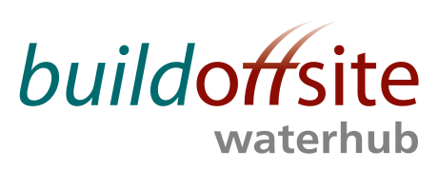
WATER HUB Leads MONTHLY CONFERENCE CALL

Date: Friday 8th September 2017

Time: 08:30 – 09:30

Skype: Join Skype Meeting

In Person: Davyhulme Waste Water Treatment Works, Trafford Way, Urmstone, M17 8DD
(Contact David Marsh if attending site)

Phone: 020 307 87637 Access code: 74947451

AGENDA

Item | Timing | Subject | Lead
1. | 08:30 – 08:35 | Welcome & Introductions | JR
2. | 08:35 | Competitions Act Agreement* | JR
3. | 08:35 – 08:45 | Actions from previous meetings  Action Log and draft Minutes attached | JR
4. | 08:45 – 09:10 | - Update on recent activities and Events  - Roadmap projects  Roadmap available on Buildoffsite website | JR
5. | 09:10 – 09:25 | Future events | JR
6. | 09:25 – 09:30 | AOB | All

* Competitions Act agreement - members participating in this call certify that they will not at any time whilst on the call engage in any form of anti-competitive practices including exchanges of price information. In addition, exchange of other financial or sales information is prohibited where, for example, it is possible to disaggregate information to identify participants.
INVITEES:
Jon Rains – Mott Macdonald (Chair)
Chris Peel – Anglian Water
Steve Hough – Balfour Beatty
Steve Fozard - Costain
David Marsh – Laing O’Rourke
Gavin Stonard - Nomenca
John Browne – United Utilities
Stephen Wright – Yorkshire Water
Jamie Johnston – Bryden Wood
Steve Weston – Ross-shire Engineering

